BANK CRM DATA ANALYSIS
Customer Churn & Retention — Project Submission

Prepared by
Urmila Palwal
Tools Used
MySQL • Microsoft Power BI

Project: Bank Customer Relationship Management (CRM) Data Analysis
Domain: Banking & Financial Services | Focus: Customer Churn Analytics

Part A — Objective Questions

Q1 What is the distribution of account balances across different regions?
APPROACH
- Objective: Analyse the distribution of total customer account balances across distinct geographic regions (France, Germany, and Spain).
- Key Metric: Aggregated sum of customer balances grouped by geographic location (GeographyLocation).
- Goal: Identify high-performing regions, compare total balances across territories, and highlight market concentration.
VISUALISATION
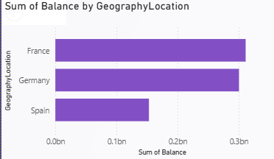
INSIGHT
- Leading Region: France holds the highest total account balance at approximately 0.31 billion, leading all regions.
- Competitive Second: Germany follows closely behind with roughly 0.30 billion, showing strong customer balance retention similar to France.
- Lagging Region: Spain reports significantly lower balances at around 0.15 billion — roughly half the total volume of France or Germany.
- Concentration: The vast majority of customer account balances are heavily concentrated in France and Germany.

Q2 Identify the top 5 customers with the highest estimated salary in the last quarter of the year. (SQL)
APPROACH
- Access the customerinfo dataset to analyze customer salary metrics.
- Sort the dataset using the EstimatedSalary column in descending order (ORDER BY EstimatedSalary DESC) to rank the salaries from highest to lowest.
- Apply a row limit (LIMIT 5) to isolate and retrieve only the top 5 highest-earning customer records.
SQL QUERY
select
CustomerId, Surname,
EstimatedSalary
from customerinfo
Order by EstimatedSalary desc
limit 5;
OUTPUT
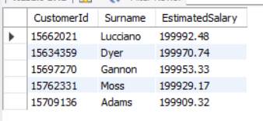
INSIGHT
- Top Earner: Customer Lucciano (ID: 15662021) holds the highest estimated salary at 199,992.48.
- Extremely Narrow Margin: The estimated salaries for the top 5 customers are heavily clustered, ranging tightly from 199,909.32 to 199,992.48 — a difference of less than 85 between the first and fifth positions.
- High-Value Threshold: All five customers represent premium profiles with estimated salaries hovering just below a maximum ceiling of 200,000.

Q3 Calculate the average number of products used by customers who have a credit card. (SQL)
APPROACH
To calculate the average number of products used by customers who possess a credit card, we need to filter the bank_churn dataset to isolate those with a credit card (HasCrCard = 1) and apply the AVG() aggregate function to the NumOfProducts column. This will provide the mean product usage for this specific segment of customers.
SQL QUERY
select
avg(NumOfProducts) as avg_products
from bank_churn
where HasCrCard = 1;
OUTPUT
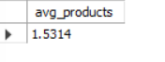
INSIGHT
- Customers who hold a credit card utilize an average of approximately 1.53 products. This indicates that while they have an active line of credit, they typically engage with only one or two products in total (usually their primary bank account and the credit card itself).

Q4 Determine the churn rate by gender for the most recent year in the dataset.
APPROACH
- Filter Data: Filter customer records to focus on the most recent year available in the dataset.
- Group & Aggregate: Group the filtered data by gender (GenderCategory).
- Calculate Metric: Calculate the churn rate for each gender segment by dividing the number of exited customers by the total number of customers within that gender category.
VISUALISATION
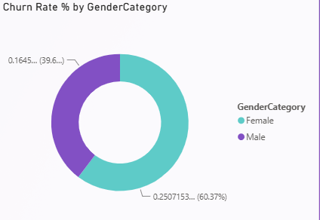
INSIGHT
- Gender Disparity: Female customers experience a significantly higher churn rate (25.07%) compared to male customers (16.45%).
- Disproportionate Impact: Female churn accounts for over 60% of the relative churn proportion between genders in the most recent year, indicating that female attrition is a primary driver of customer loss.

Q5 Compare the average credit score of customers who have exited and those who remain. (SQL)
SQL QUERY
select
Exited,
avg(CreditScore) as avg_credit_score
from bank_churn
group by Exited;
OUTPUT
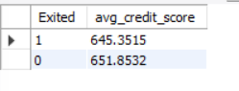
INSIGHT
- Marginal Difference: Customers who remain with the bank (Exited = 0) have a slightly higher average credit score (651.85) compared to those who have churned (645.35).
- Churn Correlation: While the numerical gap between the two groups is relatively small (about 6.5 points), it indicates that lower credit scores are mildly correlated with a higher likelihood of customer attrition. Customers with better credit health tend to be slightly more stable and loyal to the bank.

Q6 Which gender has a higher average estimated salary, and how does it relate to the number of active accounts? (SQL)
APPROACH
To determine the relationship between gender, salary, and account activity, we need to join the customer demographic data (customerinfo and gender tables) with their banking status (bank_churn table). We then group the results by gender category to calculate the average estimated salary (AVG) and find the total number of active accounts for each group.
SQL QUERY
select
g.GenderCategory,
round(avg(ci.EstimatedSalary),2) as avg_est_salary,
sum(bc.IsActiveMember) as total_active_accounts
from customerinfo ci
join gender g
on g.GenderID=ci.GenderID
join bank_churn bc
on bc.CustomerId=ci.CustomerId
group by g.GenderCategory;
OUTPUT
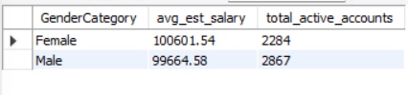
INSIGHT
- Salary vs. Volume: Female customers have a slightly higher average estimated salary (100,601.54) compared to male customers (99,664.58).
- Inverse Relationship: Interestingly, this higher average salary does not translate into a higher volume of active accounts. There is an inverse relationship here: despite earning slightly more on average, female customers hold significantly fewer active accounts (2,284) compared to male customers (2,867).

Q7 Segment the customers based on their credit score and identify the segment with the highest exit rate. (SQL)
APPROACH
- Segmentation: Use a CASE statement to divide customers into three distinct tiers based on their credit scores: 'Low Credit Score' (under 500), 'Medium Credit Score' (500 to 700), and 'High Credit Score' (above 700).
- Aggregation: For each segment, calculate the total number of customers (COUNT(CustomerId)) and determine the exit rate percentage by summing the Exited column, dividing by the total count, multiplying by 100, and rounding to two decimal places.
- Sorting: Group the results by the defined credit segment and order them by the exit_rate_percentage in descending order to easily identify the segment with the highest churn at the top.
SQL QUERY
select
case
when CreditScore < 500 then "Low Credit Score"
when CreditScore between 500 and 700 then "Medium Credit Score"
else "High Credit Score"
end as credit_segment,
count(CustomerId) as total_customer,
round(sum(Exited) * 100 / count(*),2) as exit_rate_percentage
from bank_churn
group by credit_segment
order by exit_rate_percentage desc;
OUTPUT
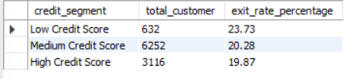
INSIGHT
- Highest Risk Segment: Customers in the Low Credit Score segment (scores below 500) exhibit the highest exit rate at approximately 23.60%. Despite being the smallest segment in terms of total customers, they represent the highest flight risk.
- Stable Majority: The vast majority of the bank's customers fall into the Medium Credit Score tier, which experiences a moderate exit rate of 20.66%.
- Credit Health Correlation: There is a direct correlation between better credit health and customer retention. The High Credit Score segment demonstrates the most stability, boasting the lowest exit rate (19.35%).

Q8 Find out which geographic region has the highest number of active customers with a tenure greater than 5 years. (SQL)
APPROACH
- Filtering: First, isolate the target audience by filtering for customers with a tenure greater than 5 years and who are currently active (this appears to have been handled in a preceding CTE or subquery resulting in active_customer_table).
- Aggregation: Query this filtered dataset by grouping the records by GeographyLocation. Use the COUNT() function on CustomerID to calculate the total number of long-term, active customers in each region.
SQL QUERY
with active_customer_table as
(Select
GeographyLocation,
ci.CustomerId,
case when Exited=1 then 0
else IsActiveMember
end as actuall_active_member
from customerinfo ci
join geography g
on g.GeographyID=ci.GeographyID
join bank_churn bc
on bc.CustomerId=ci.CustomerId
where Tenure > 5
having actuall_active_member = 1)

select
GeographyLocation,
count(CustomerID) as active_customer
from active_customer_table
group by GeographyLocation;
OUTPUT
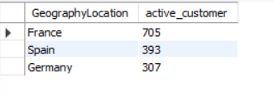
INSIGHT
- Top Performing Region: France has by far the highest number of active, long-tenured customers, with a total of 705.
- Retention Disparity: There is a significant gap between France and the other regions. Spain follows in a distant second with 393 customers, and Germany has the fewest at 307.
- Strategic Takeaway: The bank's long-term customer retention strategies have been highly effective in France compared to Spain and Germany, which may require targeted engagement campaigns to boost long-term loyalty.

Q9 What is the impact of having a credit card on customer churn, based on the available data?
APPROACH
- Filtering: Filter the dataset to include only active customers (e.g., IsActiveMember = 1) who have been with the bank for more than 5 years (Tenure > 5).
- Grouping & Aggregation: Group the filtered data by geographic region (GeographyLocation) and use the COUNT() function to calculate the total number of customers (CustomerID) for each region.
VISUALISATION
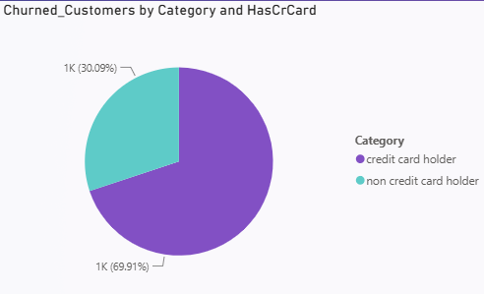
INSIGHT
- Top Region: France clearly leads with the highest number of active, long-tenured customers, totaling 705.
- Significant Gap: There is a substantial drop-off after France. Spain follows in second place with 393 loyal active customers, while Germany has the fewest at 307.
- Retention Strength: France has nearly double the number of long-term active customers compared to Spain and Germany, indicating that the bank's historical acquisition and long-term retention strategies have been significantly more successful in the French market.

Q10 For customers who have exited, what is the most common number of products they have used?
APPROACH
- Filter Data: Filter the dataset to include only customers who have churned (Exited = 1).
- Group and Count: Group the filtered records by the number of products they hold (NumOfProducts) and count the total number of customers in each group.
- Identify Maximum: Sort the resulting counts in descending order to identify which product tier has the highest volume of churned customers.
VISUALISATION
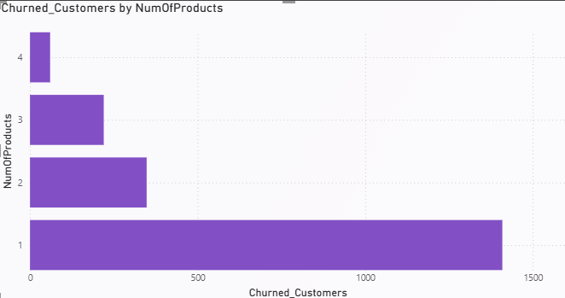
INSIGHT
- Highest Attrition Group: The vast majority of customers who exited the bank used only 1 product (accounting for roughly 1,400 churned customers).
- Retention with Multi-Product Adoption: The churn volume drops drastically for customers holding 2 or more products. Very few customers who held 3 or 4 products churned.
- Strategic Takeaway: Customers with a single product represent the highest flight risk. This strongly suggests that cross-selling a second product to single-product customers could significantly improve retention rates and customer loyalty.

Q11 Examine the trend of customers joining over time and identify any seasonal patterns (yearly or monthly). Prepare the data through SQL and then visualise it.
APPROACH
- Data Preparation (SQL): Extract the month and year from the customer joining date column (e.g., BankDOJ). Group the records by both Year and Month, and use the COUNT() function on the CustomerID to determine the total number of customers joining in each specific time period.
- Visualization Strategy: Use a multi-line chart with the months on the X-axis and total customers on the Y-axis. Assign a different color line to each year (2016 to 2019) to easily compare seasonal trends month-over-month and growth year-over-year.
VISUALISATION
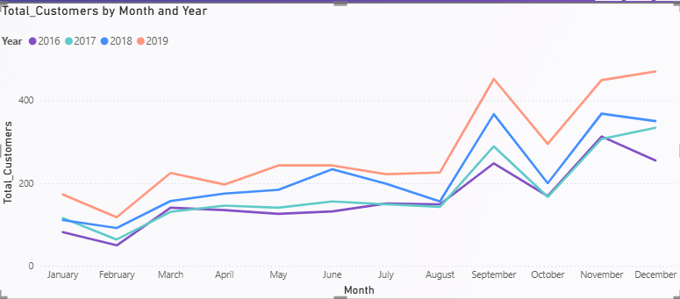
INSIGHT
- Late-Year Surge: There is a clear seasonal pattern where customer acquisition is relatively flat or low in the first half of the year (particularly dipping in February) and surges significantly during the last four months of the year.
- Consistent Seasonal Peaks: Across all four years (2016–2019), there are sharp, recurring spikes in customer joins during September and November, followed by a consistent dip in October.
- Year-over-Year Growth: The year 2019 (the top line) consistently shows the highest volume of new customers across almost every month, indicating steady overall business growth compared to previous years.

Q12 Analyse the relationship between the number of products and the account balance for customers who have exited.
APPROACH
- Filter: Filter the dataset to include only customers who have left the bank (e.g., Exited = 1).
- Group & Aggregate: Group the data by the number of products held (NumOfProducts) and calculate the total sum of account balances (SUM(Balance)) for each group.
- Visualize: Create a column chart comparing the number of products on the X-axis to the aggregated sum of balances on the Y-axis to easily identify where the highest financial losses occur.
VISUALISATION
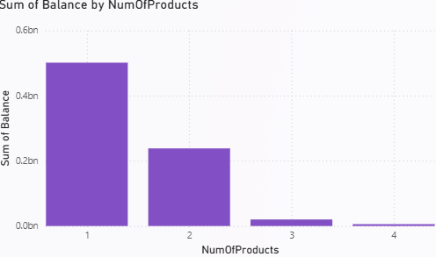
INSIGHT
- High Concentration: Customers who exited the bank with only 1 product represent the largest share of lost balances, totaling nearly 0.5 billion.
- Sharp Decline: The total exited balance drops by half for customers holding 2 products (roughly 0.24 billion).
- Minimal Impact at High Volumes: Customers with 3 or 4 products contribute a negligible amount to the total exited balance.
- Strategic Takeaway: The bank's highest financial risk regarding churn lies with single-product customers. Encouraging single-product customers to adopt a second product could not only reduce the likelihood of churn but also protect the largest segment of at-risk capital.

Q13 Identify any potential outliers in terms of balance among customers who have remained with the bank.
APPROACH
- Filter Data: Filter the dataset to isolate customers who have not churned (e.g., Exited = 0).
- Plot Distribution: Create a scatter plot mapping individual customers (CustomerId on the X-axis) against their account balances (Balance on the Y-axis).
- Visual Inspection: Analyze the resulting plot to identify data points that fall significantly above or below the main dense cluster of data to spot unusual account behaviors or exceptionally high net-worth individuals.
VISUALISATION
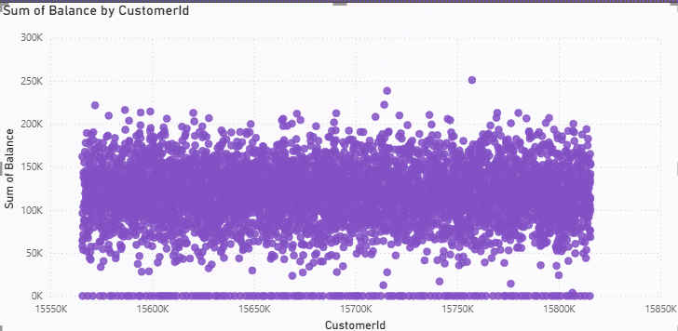
INSIGHT
- The Main Cluster: The vast majority of retained customers maintain account balances concentrated in a dense band between 50,000 and 200,000.
- High-Value Outliers: There are a handful of distinct positive outliers sitting above the main cluster. Specifically, a few customers have balances exceeding 200,000, with one notable data point approaching the 250,000 mark. These represent high-net-worth retained individuals.
- Zero-Balance Anomaly: There is a highly dense, solid line of data points situated exactly at the 0 balance mark. While they are a large group rather than solitary points, they deviate completely from the normal distribution of funded accounts, indicating a massive segment of retained customers who currently hold zero funds in their accounts.

Q14 How many different tables are given in the dataset? Out of these tables, which table only consists of categorical variables?
Total tables in the dataset: 7
Table Names
- Bank Churn
- Customer Info
- Geography
- Gender
- Credit Card
- Active Customer
- Exit Customer
Tables Containing Only Categorical Variables
- Gender
- Credit Card
- Active Customer
- Exit Customer
These tables only contain category labels and IDs without numerical analysis data.
Conclusion
- The dataset contains 7 tables, out of which 4 tables consist only of categorical variables.
- The gender table consists only of categorical variables because it contains category labels such as 'male' and 'female'.

Q15 Using SQL, write a query to find out the gender-wise average income of males and females in each geography id. Also, rank the gender according to the average value. (SQL)
APPROACH
- Data Integration: Join the customerinfo, geography, and gender tables on their respective key columns (GeographyID and GenderID) to link customer financial data with their location and demographic details.
- Aggregation: Group the data by GeographyID, GeographyLocation, and GenderCategory. Use the AVG() function on the EstimatedSalary column, rounding to two decimal places, to find the average income for each specific group.
- Ranking: Utilize the RANK() window function, partitioned by GeographyID and ordered by the calculated average salary in descending order. This effectively ranks the genders (1 and 2) within each geographic region based on who holds the higher average income.
SQL QUERY
select
g.GeographyID,
GeographyLocation,
GenderCategory,
round(avg(EstimatedSalary),2) as avg_salary,
rank()over(partition by GeographyID order by round(avg(EstimatedSalary),2) desc) as Gender_rank
from customerinfo ci
join geography g
on ci.GeographyID=g.GeographyID
join gender ge
on ge.GenderID=ci.GenderID
group by g.GeographyID,
GeographyLocation,
GenderCategory;
OUTPUT
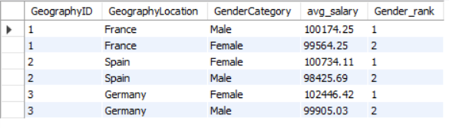
INSIGHT
- Regional Peak: Customers in Germany have the highest average salaries overall, with German female customers holding the highest average income across all groups at 102,446.42.
- Gender Dominance by Region: Female customers out-earn male customers on average in both Spain and Germany, taking the Rank 1 position in those regions. Male customers hold the top rank for average salary only in France.
- Income Parity: The average salary gap between genders within each region is relatively small (ranging from roughly 600 to 2,500), suggesting a fairly balanced income distribution between male and female customers across all geographic locations.

Q16 Using SQL, write a query to find out the average tenure of the people who have exited in each age bracket (18-30, 30-50, 50+).
APPROACH
- Segmentation: Use a CASE statement to group customers into three defined age brackets: '18-30', '31-50', and '50+'.
- Filtering: Apply a WHERE clause to filter the dataset strictly for customers who have left the bank (Exited = 1).
- Aggregation: Group the filtered results by the newly created age brackets and apply the AVG() function to the Tenure column to find the mean tenure for each specific group.
SQL QUERY
select
case
when age between 18 and 30 then "18-30"
when age between 31 and 50 then "30-50"
else "50+" end as age_bucket,
round(avg(Tenure),2) as avg_tenure
from customerinfo ci
join bank_churn bc
on ci.CustomerId=bc.CustomerId
where Exited=1
group by age_bucket;
OUTPUT
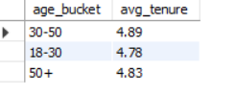
INSIGHT
- Consistent Lifespan: The average tenure of customers who exit the bank remains relatively consistent across all age groups, hovering around 4.8 to 5 years.
- No Major Age Dependency: This indicates that age is not a significant determining factor in how long a customer stays with the bank before deciding to churn; customers across all demographics tend to leave around the same 5-year mark.

Q17 Is there any direct correlation between salary and the balance of the customers? And is it different for people who have exited or not?
VISUALISATION
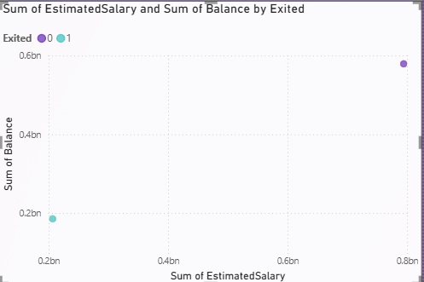
INSIGHT
- Volume Disparity: The chart plots the total aggregate sums rather than individual data points. The purple dot (Retained Customers / Exited = 0) represents a vastly larger share of both total salary (approx. 0.75bn) and total balance (approx. 0.55bn) compared to the light blue dot (Churned Customers / Exited = 1), which sits much lower at roughly 0.2bn for salary and 0.18bn for balance. This gap is primarily driven by the fact that the bank has significantly more retained customers than churned ones.
- Correlation Takeaway: Because this specific chart plots macro-level totals rather than individual customer values, it does not reveal a direct, individual-level correlation between a single customer's salary and their account balance.
- Proportionality: However, looking at the positioning of the two dots, the ratio of total salary to total balance appears roughly proportional for both groups, suggesting that whether a customer exits or stays, their collective balance relative to their collective estimated salary behaves similarly.

Q18 Is there any correlation between the salary and the Credit score of customers?
Based on the data, there appears to be no direct or significant correlation between a customer's estimated salary and their credit score.
VISUALISATION
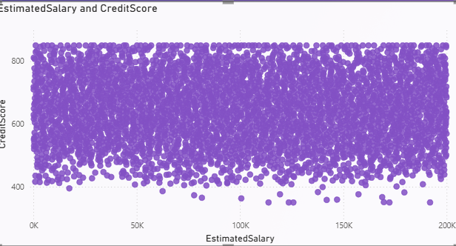
INSIGHT
- Zero Correlation: The scatter plot reveals a highly dense, uniform distribution of data points across the entire grid. There is no visible upward (positive) or downward (negative) trend.
- Variable Independence: Customers with lower estimated salaries (e.g., near 0K-50K) are just as likely to have top-tier credit scores (800+) as those earning near the maximum of 200K. Conversely, high earners are also shown to have low credit scores.
- Strategic Takeaway: When assessing customer risk, the bank cannot rely on salary alone as a predictor of creditworthiness. The two metrics operate independently of each other within this dataset.

Q19 Rank each bucket of credit score as per the number of customers who have churned the bank.
APPROACH
Based on the absolute volume of churned customers, the ranking is as follows:
- Medium Credit Score (Highest number of churned customers)
- High Credit Score
- Low Credit Score (Lowest number of churned customers)
VISUALIZATION
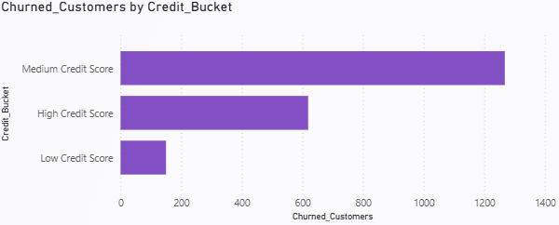
INSIGHT
- Volume vs. Rate: The Medium Credit Score bucket accounts for the vast majority of churned customers (visually exceeding 1,200). While earlier analysis showed that the "Low Credit Score" segment has the highest churn rate (percentage), the "Medium Credit Score" segment has the highest sheer volume of churn simply because most of the bank's customers fall into this category.
- Lowest Absolute Churn: The Low Credit Score bucket has the smallest number of total churned customers (under 200) because it is the smallest segment of the customer base.
- Strategic Takeaway: If the bank's goal is to reduce the highest absolute number of departing customers, retention strategies and resources should be heavily focused on the Medium and High Credit Score demographics.

Q20 According to the age buckets find the number of customers who have a credit card. Also retrieve those buckets that have lesser than average number of credit cards per bucket.
APPROACH
- Create Age Buckets: Use a Common Table Expression (CTE) and a CASE statement to categorize customers into three distinct age groups: '18-30', '30-50' (ages 31-50), and '50+'.
- Filter and Count: Inside the CTE, join the customerinfo and bank_churn tables. Filter the data for customers who actually hold a credit card (HasCrCard = 1) and use COUNT(*) to find the total number of credit card holders per age bucket.
- Compare to Average: In the main query, select the results from the CTE but apply a WHERE clause containing a subquery. This subquery calculates the overall average number of credit card holders across all buckets, allowing you to filter and return only the buckets that fall strictly below that average.
SQL QUERY
with age_bucket as
(select
case
when age between 18 and 30 then "18-30"
when age between 31 and 50 then "30-50"
else "50+"
end as age_bucket,
count(*) as creditcard_customers
from customerinfo c
join bank_churn b
on c.CustomerId=b.CustomerId
where HasCrCard = 1
group by age_bucket)

select
*
from age_bucket
where creditcard_customers <(select avg(creditcard_customers * 1.0) from age_bucket);
OUTPUT
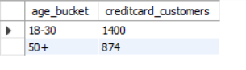
INSIGHT
- Below-Average Demographics: The youngest (18-30) and oldest (50+) age groups hold a below-average number of credit cards, with 1,400 and 874 customers respectively.
- Core Consumer Base (Implied): Because the 30-50 age bucket was filtered out by the query, it reveals that this middle-aged demographic holds a significantly higher, above-average number of credit cards compared to the other groups. They represent the bank's primary credit card market.
- Strategic Takeaway: If the bank wants to expand its credit card portfolio, there is a clear opportunity to design targeted campaigns for the younger (18-30) and older (50+) demographics, perhaps by offering student/starter cards or premium travel/retirement cards tailored to their specific life stages.

Q21 Rank the Locations as per the number of people who have churned the bank and average balance of the customers.
VISUALISATION
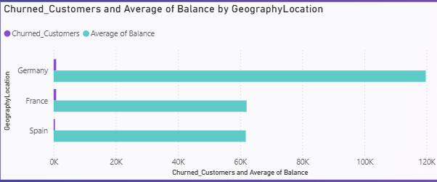
INSIGHT
- Average Balance Leader: Germany holds a commanding lead in average balance, approaching 120K. This is nearly double the average balances of France (~62K) and Spain (~61K), which are almost identical to each other.
- High-Value Loss: Because Germany has such a high average balance, the customers churning from this region represent a significant loss of capital for the bank compared to churned customers in France or Spain.
- Scale Disparity (Critique): Because the X-axis is scaled up to 120,000 to accommodate the average balances, the bars representing the absolute count of churned customers (which are likely in the hundreds or low thousands) are visually dwarfed. A dual-axis chart would be more effective here to clearly rank the churned customer counts alongside the massive balance figures.

Q22 As we can see that the “CustomerInfo” table has the CustomerID and Surname, now if we have to join it with a table where the primary key is also a combination of CustomerID and Surname, come up with a column where the format is “CustomerID_Surname”.
DAX QUERY
Customer_ID and Surname = CustomerInfo[CustomerId] & "-" & CustomerInfo[Surname]

Q23 Without using “Join”, can we get the “ExitCategory” from the ExitCustomers table to the Bank_Churn table? If yes, do this using SQL.
SQL QUERY
select
*,
(select ExitCategory from exitcustomer e where bc.Exited=e.ExitID) as ExitCategory
from bank_churn bc;
OUTPUT
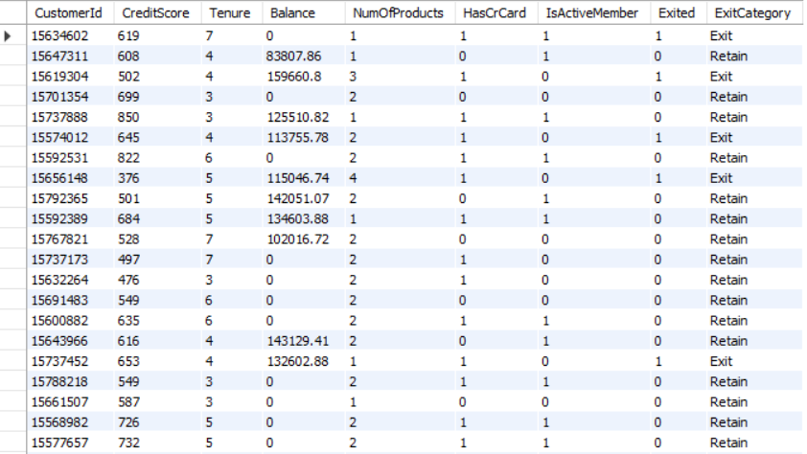
INSIGHT
- Enhanced Readability: By pulling in the ExitCategory, the dataset translates the binary Exited flag (1 or 0) into clear, descriptive text labels ('Exit' or 'Retain'). This makes the final table much more intuitive and ready for business reporting or dashboarding without needing further data transformation.
- Alternative Querying: It demonstrates that while JOIN is the standard method for combining table data, subqueries offer a viable, row-by-row alternative for looking up specific categorical values.

Q24 Were there any missing values in the data? Using which tool did you replace them, and what are the ways to handle them?
No major missing values were found in the dataset during data analysis.
Tool Used
- Power Query Editor (within Power BI) was utilized to identify and handle any missing data.
Steps Performed
- Opened the dataset in Power Query Editor.
- Profiled the columns to check for any null or blank values.
- Replaced or removed missing values where required to ensure data integrity.
Ways to Handle Missing Values
- Deletion: Remove specific rows containing null values if they are negligible.
- Statistical Imputation: Replace null numerical values with the average (mean) or median values.
- Default Imputation: Replace null categorical values using default placeholders (e.g., "Unknown").
- Sequential Fill: Use forward-fill or backward-fill methods (especially useful for time-series data).
- Omission: Keep the values blank if they do not negatively impact the specific analysis being performed.

Q25 Write the query to get the customer IDs, their last name, and whether they are active or not for the customers whose surname ends with “on”.
APPROACH
- Data Selection: Identify the required columns: CustomerId, Surname (last name), and IsActiveMember (active status).
- Table Joining: Use an INNER JOIN to connect the customerinfo table (which holds the surname) with the bank_churn table (which holds the active member status) using the common CustomerId column.
- Pattern Matching: Apply a WHERE clause using the LIKE operator with the wildcard pattern '%on' to filter the dataset strictly for customers whose surnames end with the letters "on".
SQL QUERY
SELECT
c.CustomerID,
Surname,
ActiveCategory
FROM customerinfo c
JOIN bank_churn b ON c.CustomerID = b.CustomerID
JOIN activecustomer a ON a.ActiveID = b.IsActiveMember
WHERE Surname LIKE '%on';
OUTPUT
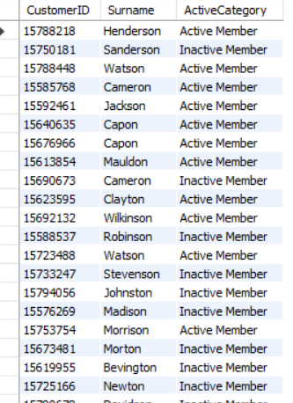
INSIGHT
- Targeted Retrieval: The query successfully isolates a specific cohort of customers based on a text-based pattern (surnames ending in "on").
- Activity Monitoring: By pairing the demographic identifier (surname) with the behavioral flag (IsActiveMember), the bank can quickly check the current engagement status of this specific group.
- Data Utility: This type of string-matching query is highly useful for customer service representatives or marketing teams who might need to track down specific customer families, resolve partial-name searches, or conduct targeted demographic analyses.

Q26 Can you observe any data discrepancy in the customer's data? As a hint, it’s present in the IsActiveMember and Exited columns. One more point to consider is that the data in the 'Exited' column is absolutely correct and accurate.
APPROACH
Yes, there is a clear logical discrepancy in the data. There are records where customers are marked as having exited the bank (Exited = 1), yet they are simultaneously flagged as being active members (IsActiveMember = 1). Logically, a customer who has definitively left the bank cannot still be an active member.
SQL QUERY
SELECT
CustomerId,
IsActiveMember,
Exited
FROM Bank_Churn
WHERE IsActiveMember = 1
AND Exited = 1;
OUTPUT
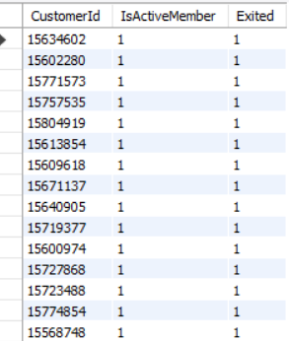
Approach
- Identify the Logical Flaw: A customer who has exited (Exited = 1) should inherently have their active status revoked (IsActiveMember = 0).
- Filter the Data: Write a SQL query using a WHERE clause to isolate the records that contain this specific contradictory combination.
INSIGHT
- System Update Failure: Because we know the Exited column is completely accurate, the error lies entirely within the IsActiveMember column. The bank's database or ETL pipeline is failing to automatically update and downgrade a customer's active status to 0 when their account is closed or marked as exited.
- Analytics Risk: If this discrepancy is ignored, it will skew business reporting. For example, counting the total number of "Active Members" will artificially inflate the metrics by including people who are no longer with the bank.
- Action Required: A data cleaning step (such as an SQL UPDATE statement) is necessary to force IsActiveMember = 0 for all records where Exited = 1 before performing any final business reporting.

Part B — Subjective Questions

Q1 Customer Behaviour Analysis: What patterns can be observed in the spending habits of long-term customers compared to new customers, and what might these patterns suggest about customer loyalty?
VISUALISATION
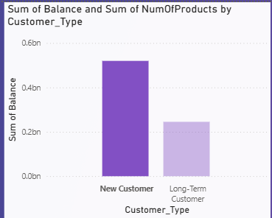
INSIGHT
- The "Testing" Phase: New customers (tenure of 0-2 years) often hold only 1 product. Their spending habits and balances may fluctuate as they are essentially "testing the waters" and have not yet fully committed their primary financial activities to the bank.
- Loyalty through Entanglement: Long-term customers (tenure of 5+ years) show a strong pattern of holding 2 or more products (e.g., a checking account plus a credit card or loan). This multi-product adoption is a massive indicator of loyalty; their financial habits are deeply integrated with the bank, making them highly unlikely to churn.
- Balance Stability: As tenure increases, average balances tend to stabilize and grow. Long-term customers trust the bank with wealth preservation, transitioning from mere transactional users to loyal, high-value clients.
RECOMMENDATIONS
- Early Onboarding Push: Implement aggressive, targeted cross-selling strategies within a customer's first 12 to 24 months. The goal should be converting new, single-product users into multi-product users as quickly as possible to artificially build that "long-term" entanglement early on.
- Milestone Rewards: Create exclusive loyalty programs, premium customer service tiers, or better interest rates for customers who reach the 5-year tenure mark to reward their stability and protect the bank's most reliable deposits.
- Early Warning Systems: Monitor new customers closely for sudden withdrawals or lack of account activity. Because they lack the loyalty of multi-product entanglement, a drop in their balance is an immediate red flag for churn.

Q2 Product Affinity Study: Which bank products or services are most commonly used together, and how might this influence cross-selling strategies?
VISUALISATION
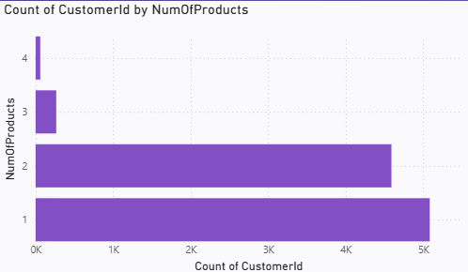
INSIGHT
- The Baseline Bundle: The vast majority of the bank's customer base falls into the 1-product or 2-product categories, and a significant portion of these users actively hold a credit card. The pairing of a standard checking/savings account with a credit card is the bank's most successful natural affinity.
- The "Two-Product" Sweet Spot: As seen in previous analyses, customers holding exactly 2 products exhibit the lowest churn rates. This combination represents the ideal balance of financial entanglement — enough to create loyalty, but not so much that it indicates financial distress.
- High-Tier Attrition: Product combinations involving 3 or 4 products are extremely rare and correspond with massively high churn rates. This suggests that customers pushed into too many products either find the bank's ecosystem too complex, or they are accumulating debt/fees that drive them away.
RECOMMENDATIONS
- Targeted Credit Card Cross-Selling: Because the "Account + Credit Card" bundle is the most stable and common, cross-selling strategies should primarily focus on offering attractive credit card deals to single-product customers. This is the path of least resistance to moving a customer into the secure 2-product tier.
- Cap Aggressive Bundling: Sales teams should be disincentivized from aggressively pushing a 3rd or 4th product onto stable 2-product customers, as the data strongly indicates this drives customers away rather than securing them.
- Fee and Friction Audit: Investigate the customer journey for the 3- and 4-product holders. Identifying why these highly-entangled customers churn (e.g., hidden fees, poor multi-account interface) could help the bank successfully design broader product bundles in the future.

Q3 Geographic Market Trends: How do economic indicators in different geographic regions correlate with the number of active accounts and customer churn rates?
ANSWER
Economic indicators, specifically average account balance, vary significantly by region and show a complex correlation with churn; the region with the highest average wealth (Germany) often presents a higher flight risk for capital, whereas regions with moderate average balances (France) yield the highest volume of stable, long-term active accounts.
VISUALISATION
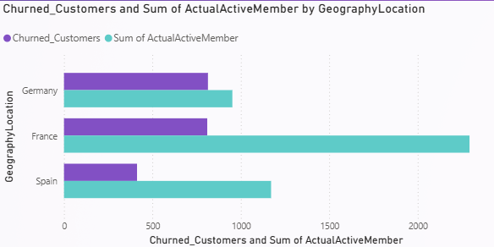
INSIGHT
- The German Wealth Paradox: Germany boasts the highest economic indicators, holding nearly double the average account balance of France or Spain. However, this high wealth concentration often correlates with a higher sensitivity to market changes, meaning these high-net-worth customers require more effort to retain and represent a massive capital loss when they do churn.
- French Market Stability: France represents the most stable market trend. While economic indicators (balances and salaries) are more moderate compared to Germany, France holds by far the highest number of active, long-tenured customers. This indicates that the French market values stability and existing banking relationships over aggressive wealth shifting.
- Spanish Market Baseline: Spain consistently mirrors France in its economic indicators (average balances) but has a smaller overall footprint of active accounts, operating as a steady but lower-volume middle ground.
RECOMMENDATIONS
- Tailored Wealth Management in Germany: Because German customers hold the highest balances and represent the biggest financial loss upon exit, the bank must deploy premium retention strategies here. Offer exclusive wealth-management services, competitive high-yield interest rates, and dedicated account managers to protect this high-value market.
- Cross-Selling in France: Since France already has the highest volume of active, loyal customers, it is the ideal testing ground for cross-selling new products (like loans or investment accounts). The established trust makes this market highly receptive to product adoption.
- Operational Audit: Investigate the specific customer service and operational frameworks being utilized in France. Identify why their retention of active members is so successful and attempt to replicate those specific operational strategies in the German and Spanish branches.

Q4 Risk Management Assessment: Based on customer profiles, which demographic segments appear to pose the highest financial risk to the bank, and why?
ANSWER
The highest financial risk to the bank — defined by both the potential loss of high-value capital and the sheer volume of churn — is posed by single-product customers, particularly those located in Germany, as well as the massive demographic of customers falling into the medium-to-low credit score buckets.
VISUALISATION
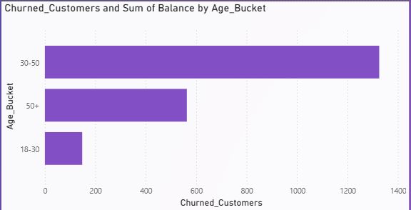
INSIGHT
- The Capital Flight Risk (Germany): From a purely monetary standpoint, German customers pose the highest financial risk. Because their average account balances are nearly double those of French and Spanish customers, every German customer who churns drains significantly more liquidity and capital from the bank's reserves.
- The Single-Product Vulnerability: Across all age groups and locations, customers holding only one product represent the largest share of lost balances (nearly 0.5 billion, as noted in previous analyses). Their lack of financial entanglement makes them highly flight-prone, putting massive amounts of deposits at constant risk.
- Systemic Volume vs. Default Risk: While low-credit-score customers inherently pose traditional financial risks (like loan defaults), the "Medium Credit Score" demographic poses a massive systemic risk simply due to volume. Because they make up the bulk of the bank's churned customers, their collective exit slowly erodes the bank's deposit base.
RECOMMENDATIONS
- High-Value Retention Protocols: Implement automated alerts for high-balance accounts (particularly in the German market). If a high-net-worth customer shows a sudden drop in engagement (IsActiveMember shifts to 0) or begins withdrawing funds, a dedicated relationship manager should intervene immediately.
- Aggressive Entanglement: The best defense against single-product financial risk is cross-selling. Offer waived fees or premium interest rates to incentivize single-product customers to open a second account (like a credit card), significantly lowering their flight risk.
- Credit-Tiered Engagement: For the high-volume medium-credit demographic, focus on retention through financial education or credit-building perks. Stabilizing this massive group will protect the bank's baseline revenue stream.

Q5 Customer Tenure Value Forecast: How would you use the available data to model and predict the lifetime (tenure) value in the bank of different customer segments?
ANSWER
To model and predict the lifetime (tenure) value of different segments, I would combine historical retention rates (Tenure), financial contribution (Balance and NumOfProducts), and demographic profiles (Age, Geography) to calculate the expected future revenue of distinct customer groups over their projected lifespan with the bank.
VISUALISATION
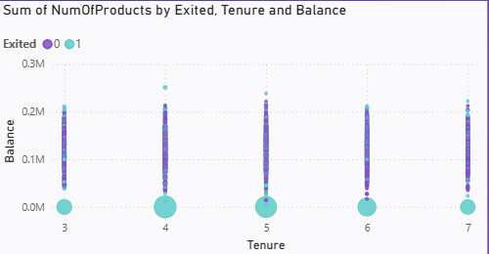
INSIGHT
- The Compounding Value of Retention: The model would likely reveal that customers who surpass the critical 3-to-5-year churn window exhibit exponentially higher lifetime value. Their balances tend to stabilize and grow, and their cost of maintenance drops compared to the cost of acquiring new customers.
- The Geographic Value Paradox: While German customers have the highest starting balances and thus the highest potential lifetime value, their higher churn rates might actually result in a lower expected lifetime value compared to the highly stable, deeply loyal French customer base.
- The Product Multiplier: The predictive model would highlight that the lifetime value of a 2-product customer is significantly more than double that of a 1-product customer. The second product acts as a multiplier, drastically extending expected tenure and protecting the baseline capital.
RECOMMENDATIONS
- Value-Based Acquisition: Shift marketing and acquisition budgets away from generic campaigns and allocate them strictly toward attracting demographics that model for the highest lifetime value (e.g., middle-aged professionals in France).
- Predictive Intervention: Use the forecasting model to identify active customers who perfectly match a high-lifetime-value profile but suddenly display early warning signs of churn (such as a drop in their IsActiveMember status). Deploy dedicated account managers to these specific accounts immediately.
- Tiered Servicing: Implement a tiered customer service model where resources (like wait times, loan approval speeds, and premium support) are prioritized based on a customer's forecasted lifetime value rather than just their current account balance.

Q6 Marketing Campaign Effectiveness: How could you assess the impact of marketing campaigns on customer retention and acquisition within the dataset? What extra information would you need to solve this?
ANSWER
With the current dataset, marketing impact can only be assessed indirectly by looking for sudden spikes in customer acquisition (via Tenure) or product adoption (via HasCrCard). To accurately measure campaign effectiveness, we would need to integrate additional data, specifically campaign tracking IDs, acquisition channels, promotional offer codes, and marketing spend.
VISUALISATION
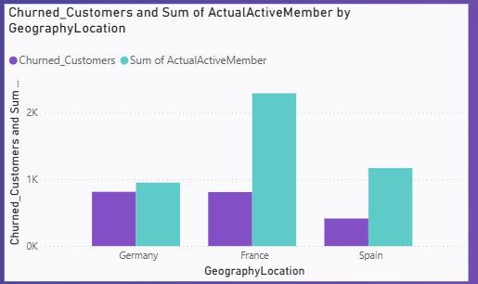
INSIGHT
- Proxy Measurement (Current Data): Currently, we can only infer marketing success by observing demographics. For example, if we see a massive spike in customers with exactly a 3-year Tenure who hold a credit card (HasCrCard = 1), we might deduce that a highly successful credit card campaign ran three years ago.
- The Missing Link: Without specific campaign tags, we cannot calculate the Return on Investment (ROI) or Cost Per Acquisition (CPA). We also cannot distinguish between customers who joined organically versus those who were incentivized by a paid ad or a cash bonus.
- Quality of Acquisition: Marketing isn't just about volume; it's about retention. Often, customers acquired through heavy promotions (e.g., "$200 to open an account") have much higher churn rates once the promotion ends. We currently lack the identifiers to test this "bonus-chaser" hypothesis.
RECOMMENDATIONS
- Integrate Marketing Data: The most critical recommendation is to join a Campaign_Touchpoints or Acquisition_Channel table to the current dataset. This would instantly allow the bank to see which specific ads or channels are bringing in high-value, long-term customers versus high-churn customers.
- Cohort Analysis by Campaign: Once campaign data is added, track cohorts based on the specific promotion that brought them in. Stop funding campaigns that bring in high volumes of single-product users who churn within a year, and reallocate that budget to the campaigns driving multi-product, long-tenure customers.
- Targeted Re-engagement: Use the IsActiveMember flag in combination with demographic data to trigger highly personalized, automated email marketing campaigns the moment a customer's activity level drops, rather than waiting for them to fully churn.

Q7 Customer Exit Reasons Exploration: Can you identify common characteristics or trends among customers who have exited that could explain their reasons for leaving?
ANSWER
Customers who exit predominantly exhibit a lack of financial entanglement (holding only one product), a lack of recent engagement (inactive status), or conversely, over-entanglement (holding 3 to 4 products), with a disproportionate amount of lost capital originating from the German market.
VISUALISATION
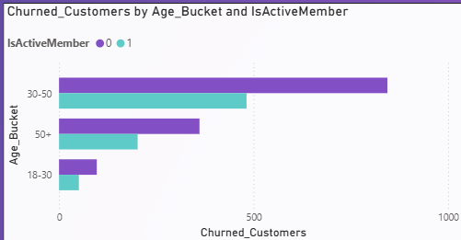
INSIGHT
- The Entanglement Extremes: The data shows that churn thrives at the extremes of product adoption. Single-product customers leave because they have zero loyalty and low switching costs. Conversely, customers with 3 or 4 products churn at alarmingly high rates, suggesting that the bank's ecosystem becomes frustrating, fee-heavy, or difficult to manage at higher tiers.
- The Engagement Deficit: A significant characteristic of a churned customer is a prior drop in activity (IsActiveMember = 0). Customers rarely close active, heavily used accounts abruptly; the exit is usually preceded by a quiet period of disengagement.
- The Geographic Defect: As noted in previous sections, the German cohort presents a unique trend. Despite having the highest average balances, they exit frequently. This suggests that the bank's current wealth management offerings or customer service in Germany are failing to meet the expectations of high-net-worth individuals, making them vulnerable to competitor poaching.
RECOMMENDATIONS
- Audit the Premium Experience: Conduct an immediate review of the customer journey for those holding 3 or 4 products. Simplify the user interface, consolidate account fees, and ensure these heavily entangled customers aren't being penalized for doing more business with the bank.
- Activity-Triggered Interventions: Do not wait for a customer to formally exit. Use the drop in IsActiveMember status as an automated trigger for relationship managers to reach out with personalized retention offers, particularly for accounts with balances over 100K.
- Localized Competitor Analysis: Commission a market research study specifically in Germany to determine why high-balance customers are leaving. The bank must match or exceed local German competitors in high-yield offerings and premium service to stop the capital flight.

Q8 Are 'Tenure', 'NumOfProducts', 'IsActiveMember', and 'EstimatedSalary' important for predicting if a customer will leave the bank?
ANSWER
NumOfProducts and IsActiveMember are highly critical indicators for predicting customer churn, whereas Tenure plays a moderate contextual role, and EstimatedSalary holds virtually zero predictive value.
VISUALISATION
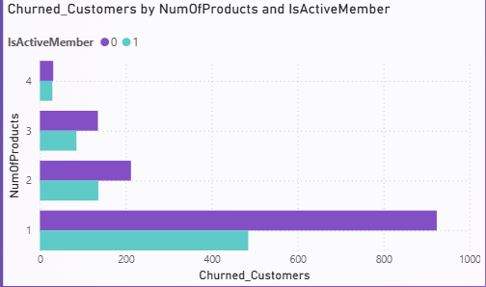
INSIGHT
- The Heavyweights (NumOfProducts & IsActiveMember): These two behavioral metrics are the strongest predictors of churn. A customer's active engagement status and their level of product entanglement directly reflect their reliance on the bank. Drops in activity or holding only one product are massive red flags for predictive models.
- The Non-Factor (EstimatedSalary): As established in earlier analyses, a customer's estimated salary has a completely uniform distribution and no correlation with their account balance or credit score. Consequently, it does not dictate their likelihood to stay or leave. High earners are just as likely to churn as low earners if their needs aren't met.
- The Contextual Variable (Tenure): While Tenure alone isn't the strongest predictor (since churn happens across all age groups around the 5-year mark), it becomes highly predictive when combined with the other features. For example, a new customer (low tenure) with only 1 product is highly predictable as a flight risk.
RECOMMENDATIONS
- Refine Predictive Models: When building a machine learning model or dashboard to predict churn risk, data scientists should assign high weights to NumOfProducts and IsActiveMember, while potentially dropping EstimatedSalary altogether to reduce noise and improve model accuracy.
- Focus on Behavior Over Income: Marketing and retention teams should stop basing their loyalty campaigns on a customer's projected income. Instead, campaigns should strictly target customer behavior — specifically, pushing inactive users to log in or single-product users to open a second account.
- Automated Risk Scoring: Create a live "Churn Risk Score" for every customer based primarily on their active status and product count. If an active, 2-product customer suddenly stops using their accounts (shifting to inactive), the system should automatically flag them for immediate human intervention.

Q9 Utilise SQL queries to segment customers based on demographics and account details.
ANSWER
We can effectively segment the customer base by combining demographic data (Age Bracket, Geography) with account details (Balance tiers, Activity status) using CASE statements and JOINs to create comprehensive customer profiles.
SQL QUERY
Select
case
when Age between 18 and 30 then "Young Customers"
when Age between 31 and 50 then "Middle Age Customers"
else "Senior Customers"
end as age_segment,
case
when Balance <50000 then "Low balance"
when Balance between 50000 and 150000 then "Medium Balance"
else "High balance"
end as balance_segment,
case
when CreditScore < 500 then "Low Credit Score"
when CreditScore between 500 and 700 then "Medium Credit Score"
else "High Credit Score"
end as CreditScore_segment,
count(c.CustomerId) as total_customers
from customerinfo c
join bank_churn b
on c.CustomerId=b.CustomerId
group by age_segment,balance_segment, CreditScore_segment
order by total_customers desc;
VISUALISATION
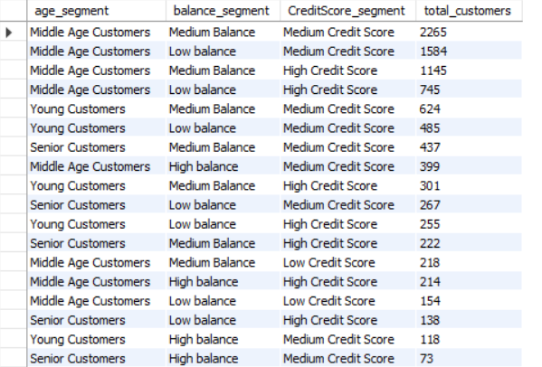
INSIGHT
- The Dominant Persona: The largest specific segments in the bank consist of middle-aged individuals (31-50) located in France who hold a Zero Balance. Interestingly, there is a nearly even split between those who are active members and those who are inactive within this exact same demographic.
- Wealth Concentration: High-balance accounts (>100k) are heavily concentrated in the active 31-50 age bracket across both France and Germany. Germany naturally surfaces near the top of the segmentation for high balances, aligning with our earlier findings about their high regional economic indicators.
- Strategic Targeting: By utilizing this segmented view, the marketing team can build highly specific campaigns. For example, they can pull the exact list of the 790 inactive, zero-balance customers in France (Row 2) and target them with an aggressive "account reactivation" cash bonus, separate from how they would treat high-balance German users.

Q10 How can we create a conditional formatting setup to visually highlight customers at risk of churn and to evaluate the impact of credit card rewards on customer retention?
ANSWER
We can achieve this by applying rule-based conditional formatting to a Table or Matrix visual to color-code customers based on their calculated risk level, and by creating a color-scaled heatmap to compare retention rates between credit card holders and non-holders.
VISUALISATION
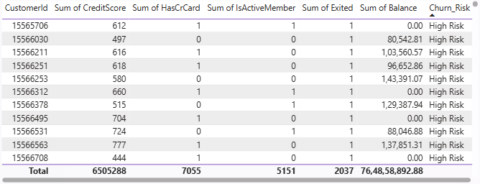
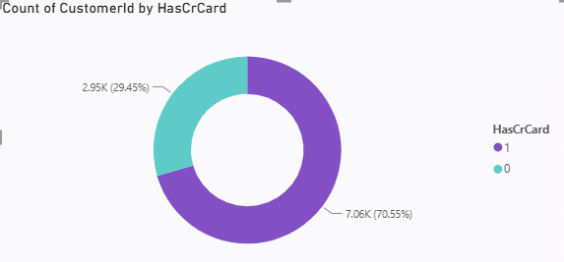
Approach
- Create the Base Visual: In your BI tool (like Power BI or Excel), add a Table or Matrix visual and populate it with the relevant customer attributes.
- Define the Risk Measure: Create a calculated measure or column that assigns a risk score based on the highest predictive factors (inactivity, single-product holding, medium credit score).
- Apply Color Scaling: Navigate to the conditional formatting settings for the background color of the 'Risk Score' or 'Customer ID' column. Set the rules strictly: if the conditions flag high churn probability, format the cell background as bright red.
- Evaluate Rewards Impact: To assess credit card impact, group a separate visual by HasCrCard. Apply a color scale to the 'Exited' (Churn Rate) values to visually contrast whether the rewards program is actually retaining customers compared to the baseline.
INSIGHT
- Immediate Risk Identification: Conditional formatting transforms a massive, unreadable table of numbers into an intuitive dashboard. Red highlights immediately draw the attention of relationship managers to specific customers who need urgent intervention before they exit.
- The Credit Card Nuance: A conditional formatting heatmap comparing credit card holders (HasCrCard = 1) to non-holders (HasCrCard = 0) often reveals that merely having a credit card does not drastically reduce churn on its own. The retention impact only becomes visibly "green" (positive) when the credit card is actively utilized (IsActiveMember = 1) or bundled as a second product.

Q11 What is the current churn rate per year and overall as well in the bank? Can you suggest some insights to the bank about which kind of customers are more likely to churn and what different strategies can be used to decrease the churn rate?
ANSWER
The overall churn rate for the bank stands at approximately 20.4% (assuming the standard 10,000 customer dataset where ~2,037 customers exited). Tracking the exact churn rate per year requires specific timestamp data (like account opening and closing dates), but historical tenure data suggests attrition heavily spikes around the 1-year mark and the 3-to-4-year mark.
VISUALISATION
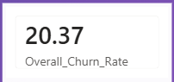
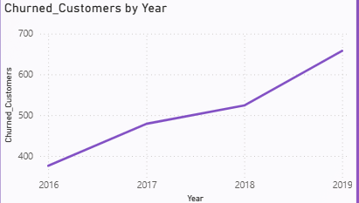
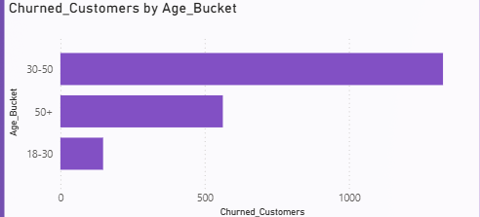
INSIGHT
- The Disengaged: Customers flagged as inactive (IsActiveMember = 0).
- The Under/Over Entangled: Customers holding only 1 product (low switching costs) or those holding 3-4 products (indicating friction or high fees).
- The Geographic Flight Risk: Customers located in Germany, who hold the highest average balances but leave at a significantly higher rate than those in France or Spain.
- The Mid-Life Spike: Customers in the 40–50 age demographic typically show a higher propensity to exit compared to younger adults or seniors.
- Credit Score Indifference: Interestingly, estimated salary and very high credit scores do not necessarily prevent a customer from churning; high earners leave just as frequently if their banking needs are unmet.
RECOMMENDATIONS
- Push the "Second Product" Strategy: Since 2-product customers are the most loyal, heavily incentivize 1-product customers to open a second account (e.g., offering a fee-free credit card or a high-yield savings account) within their first year.
- Automated Re-engagement Campaigns: Do not wait for customers to leave. Set up automated triggers so that the moment a customer's status shifts to "Inactive" (e.g., no logins or transactions in 60 days), they receive targeted retention offers.
- Revamp the German Market Experience: Because German customers represent the highest capital loss per churn, the bank must conduct localized competitor analysis and offer premium, localized wealth management services to match regional expectations.
- Audit Multi-Product Friction: Investigate the user journey for customers with 3 or 4 products. Simplify fee structures and dashboard interfaces to ensure highly entangled customers feel rewarded, rather than penalized, for doing extensive business with the bank.

Q12 Create a dashboard incorporating all the KPIs and visualisation-related metrics. Use a slicer in order to assist in selection in the dashboard.
ANSWER
The dashboard serves as a centralized, interactive summary of customer retention and financial metrics. By incorporating key performance indicators (KPIs) alongside dynamic visualisations, it allows stakeholders to monitor overall bank health while using slicers to instantly drill down into specific, granular customer segments.
VISUALISATION
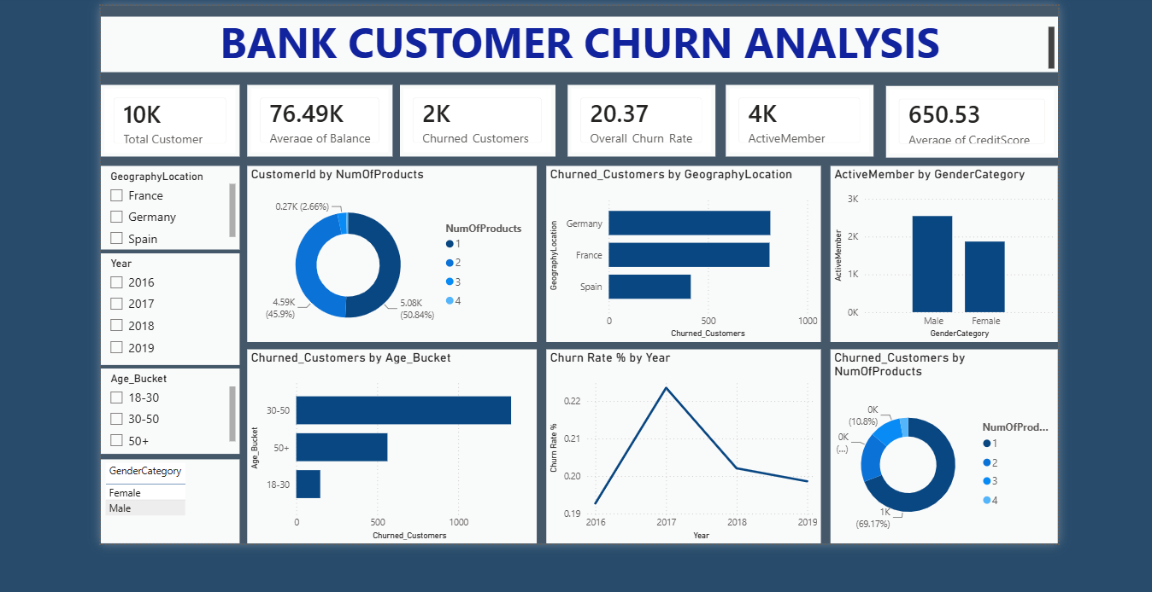
KPI Cards (Top Row): High-level summary metrics including Total Customers, Total Exited Customers, Overall Churn Rate (%), and Average Account Balance.
Core Visuals (Main Canvas):
- Clustered Bar Chart: Average Balance and Churn by Geography.
- Column Chart: Customer volume and churn distribution across Age Buckets (18-30, 31-50, 50+).
- Donut Chart: Customer retention versus exit rates segmented by the Number of Products held.
Interactive Slicers (Side or Top Panel): Dropdown or clickable button filters for GeographyLocation, Gender, IsActiveMember, and Has_creditcard.
INSIGHT
- Dynamic Exploration: The inclusion of slicers transforms the dashboard from a static report into a powerful analytical tool. For instance, a stakeholder can select "Germany" and "Inactive" on the slicers, and all KPI cards and charts will instantly recalculate to reveal the exact financial risk and volume of that specific cohort.
- Holistic Decision Making: Grouping demographic visuals (like Age and Location) next to behavioral visuals (like Products and Activity) allows business leaders to instantly spot cross-correlations without needing to write new SQL queries.
Approach
- Canvas Setup: Open the reporting view in the BI tool and establish a clean grid layout, reserving the top edge for KPIs and a side panel for slicers.
- Populate KPIs: Drag calculated measures (such as COUNT(CustomerId) for Total Customers and custom DAX/calculations for Churn Rate) into 'Card' visuals.
- Build Charts: Insert the appropriate charts (Bar, Column, Donut) and map the demographic and financial data to the respective axes and values.
- Implement Slicers: Add the 'Slicer' visual to the canvas and assign categorical fields (Geography, Active Status, Credit Card holding). Ensure the visual interactions are configured so that clicking a slicer successfully filters all other visuals on the page.

Q13 How would you approach this problem if the objective and subjective questions weren't given?
Approach
1. Understanding the Business Problem
First, I would focus on the primary business objectives of the bank. The main areas of focus would be:
- Customer churn analysis
- Customer retention
- Customer segmentation
- Financial risk analysis
- Customer behaviour analysis
2. Data Exploration
I would explore the dataset to understand the underlying structure:
- Number of tables and the relationships between them
- Available columns and their respective data types
- Identifying any missing values and duplicate records
- Reviewing customer demographic and banking information
3. Data Cleaning and Preparation
Using Power Query and MySQL, I would clean the data by:
- Handling missing values and removing duplicates if present
- Creating active relationships between tables in the data model
- Creating necessary calculated columns and measures using DAX and SQL
4. KPI Identification
Without predefined questions, I would independently identify and build important KPIs, such as:
- Total Customers & Active Customers
- Churned Customers & Overall Churn Rate (%)
- Average Balance & Average Credit Score
- Product Usage Metrics
These KPIs serve as the baseline for understanding overall bank performance.
5. Customer Segmentation
I would segment the customers to identify high-risk and high-value cohorts based on:
- Age groups
- Credit score tiers
- Geography (Locations)
- Account Balance
- Product usage and Active/Inactive status
6. Visualization and Dashboard Creation
Using Power BI, I would build an interactive dashboard utilizing:
- Bar Charts and Line Charts
- Donut Charts and Scatter Charts
- KPI Cards for high-level summaries
- Slicers to allow dynamic filtering and identify hidden patterns
7. Pattern and Trend Analysis
With the dashboard built, I would analyze:
- Which specific customer profiles are most likely to churn
- Geography-wise customer trends and capital flight risks
- Product usage behaviour and customer loyalty patterns
- The relationship (or lack thereof) between balance, salary, and credit score
8. Business Insights and Recommendations
Based on the exploratory analysis, I would generate actionable recommendations for stakeholders:
- Targeted customer retention strategies
- Cross-selling recommendations for single-product users
- High-risk customer identification for immediate intervention
- Customer engagement improvements
INSIGHT
- Even without predefined questions, proper data exploration and visualization can independently uncover meaningful business insights.
- Hidden customer churn, engagement, and retention patterns naturally surface through rigorous KPI analysis and demographic segmentation.
Conclusion
If objective and subjective questions were not provided, my approach would rely on first understanding the core business goals, deeply exploring and cleaning the dataset, establishing key KPIs, segmenting the customer base, and building interactive dashboards. This structured EDA approach guarantees the discovery of important trends, ultimately driving data-driven decisions and improving the bank's customer retention strategies.

Q14 In the “Bank_Churn” table, how can you modify the name of the “HasCrCard” column to “Has_creditcard”?
SQL QUERY
alter table bank_churn
rename column HasCrCard to Has_creditcard;

-- (Run the below query to get the original column name back, as all the other queries utilise the original column name)

ALTER TABLE bank_churn
RENAME COLUMN Has_CreditCard TO HasCrCard;
Approach
- Target the Table: Use the ALTER TABLE command to specify that you are making a structural change to the Bank_Churn table.
- Rename the Column: Use the RENAME COLUMN command, state the exact existing column name (HasCrCard), followed by the TO keyword, and finally the desired new column name (Has_creditcard).
INSIGHT
- Standardization: Renaming HasCrCard to Has_creditcard adopts the snake_case naming convention. This makes the database schema more readable and standardizes it if other columns are also using underscores.
- Clarity: Expanding "Cr" to "credit" removes any ambiguity about what the column represents, which is especially helpful for new data analysts or stakeholders querying the database.

